Create Network source with ORM Stack

Contents

1. Introduction 3
2. Workflow diagram to deploy the stack 3
3. Create stack for the Network source on “Default Domain” 4
4. Plan the Job 7
5. Apply the Job 7
6. Verify in the Console 9
7. Destroy the stack 9

Introduction
This resource provides the Network Source resource in Oracle Cloud Infrastructure Identity service. OCI, or Oracle Cloud Infrastructure, is a cloud computing service provided by Oracle that allows users to create and manage a wide range of cloud-based resources, including compute instances, storage, networking, and more.

In OCI, a network source refers to a specific set of rules that define how traffic can flow in and out of a particular network resource, such as a compute instance or a load balancer. These rules typically include information such as the allowed protocols and ports, the source and destination IP addresses, and any other network security policies that should be enforced.

Workflow diagram to deploy the stack
Below diagram shows how the Terraform Artifact are applied in the OCI. While creating a ORM stack, using terraform deliverables Init, Plan and Apply is the flow to provision the resource in the OCI. We can have the deliverables in any of below.
- GitLab/GitHub Repo
- Bitbucket
- Can be in folder/.zip in the local disk
- Object Storage Bucket
- Can be in compartment
- Oracle provided Template


Pre-request:
- CIDR Block.
- Compartment ocid.
- It created only in the root compartment.

Create stack for the Network source on “Default Domain”

Go to OCI Console Developer Services Resource Manager Stacks select the compartment Create Stack

My Configuration Folder Browse Select the “nonprod vcn” folder that contains the terraform Upload

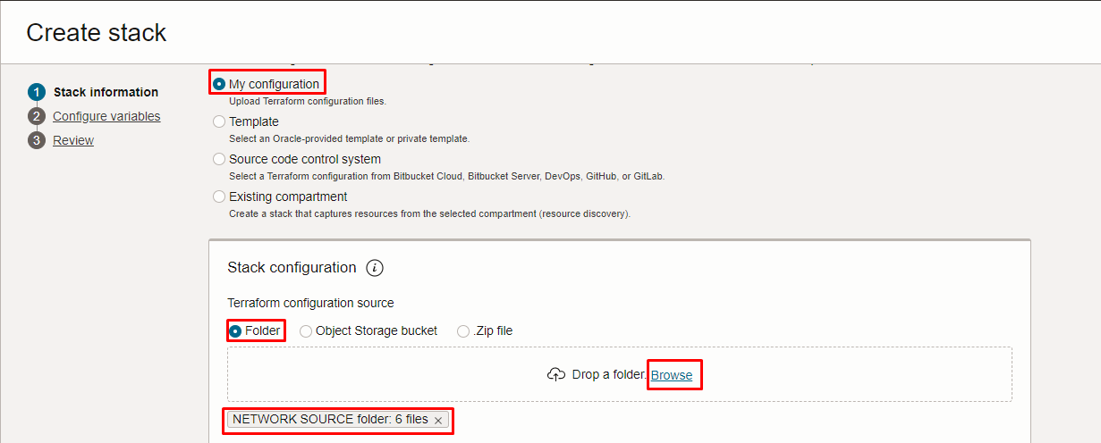
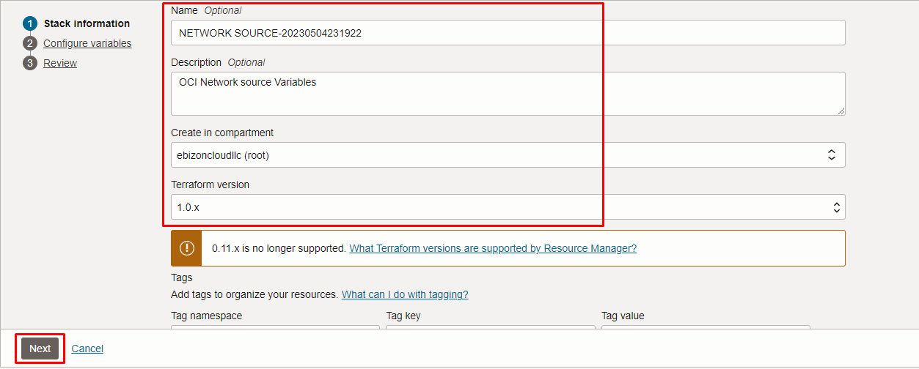

Click “NEXT”

Select the parameters as per the below screen,
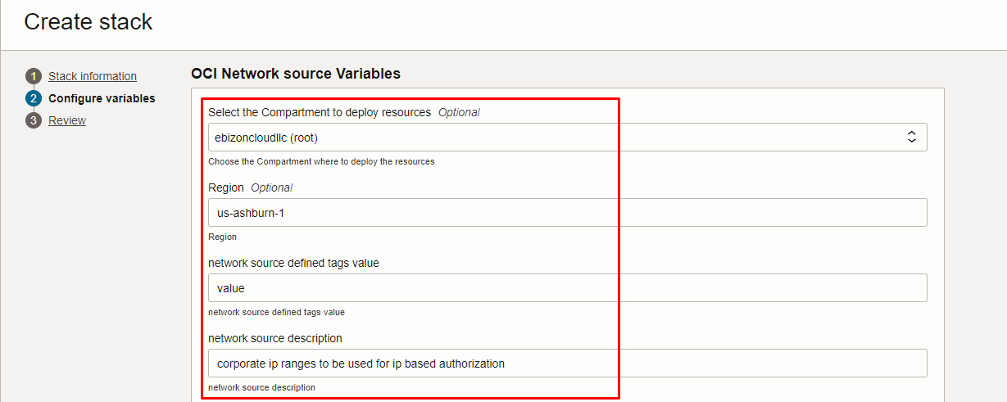
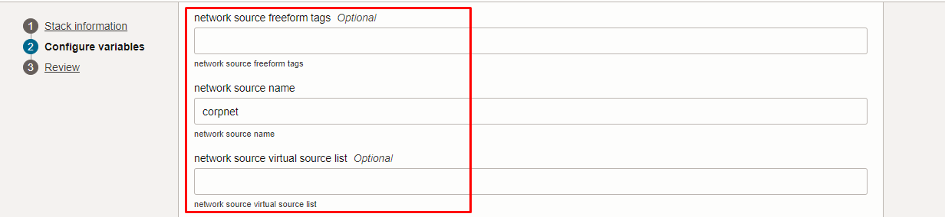

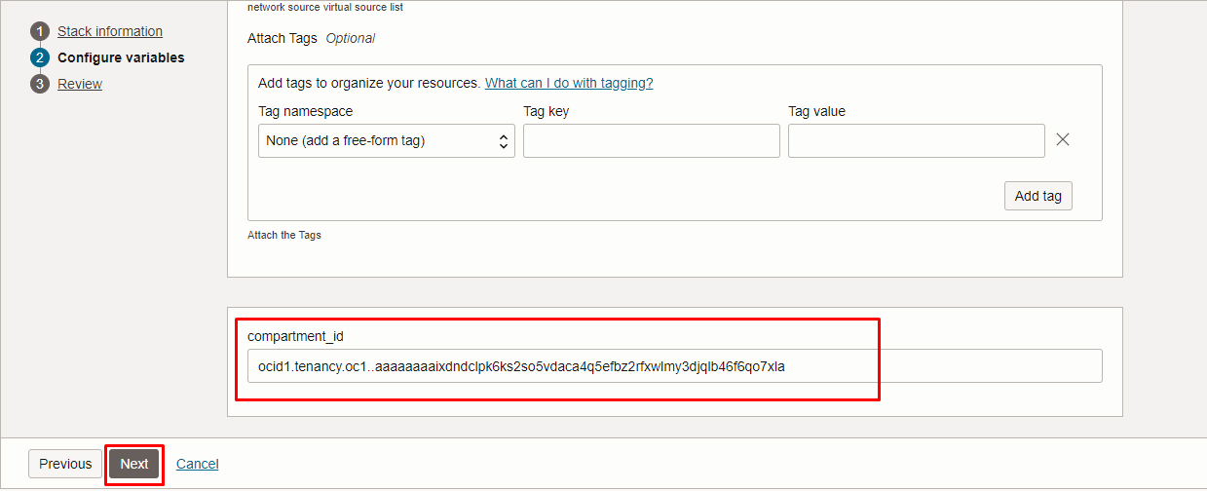

Click “NEXT” Click “CREATE”

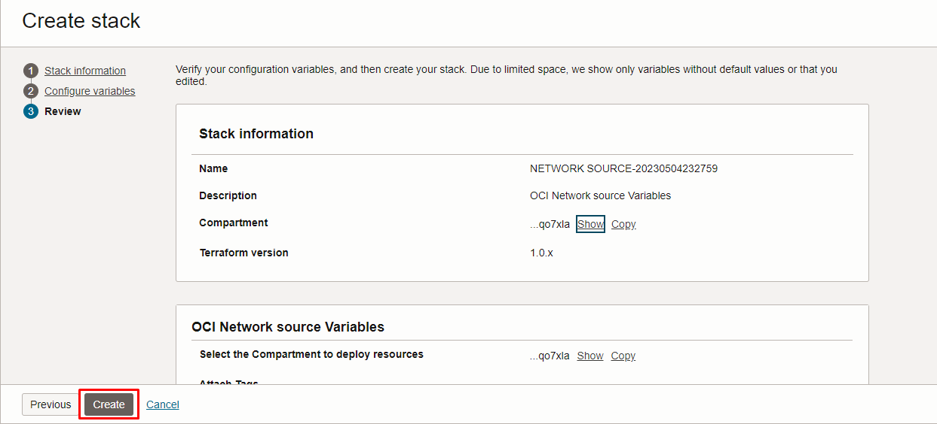

Plan the Job

Click the “Plan”

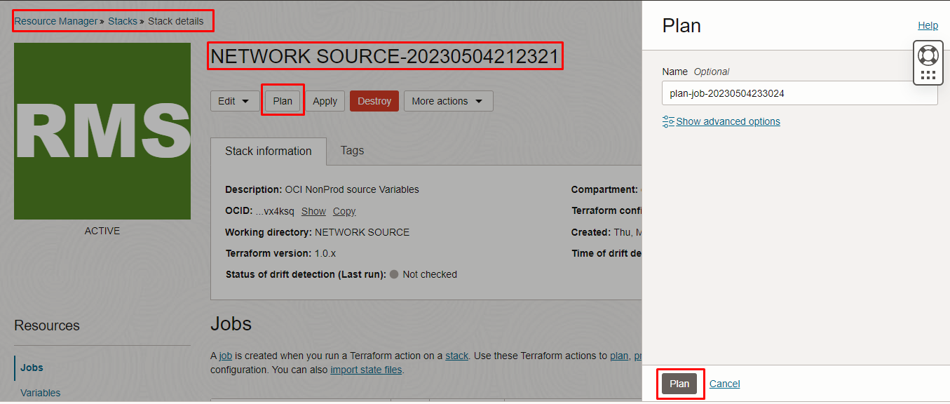

Verify the Plan is successful.

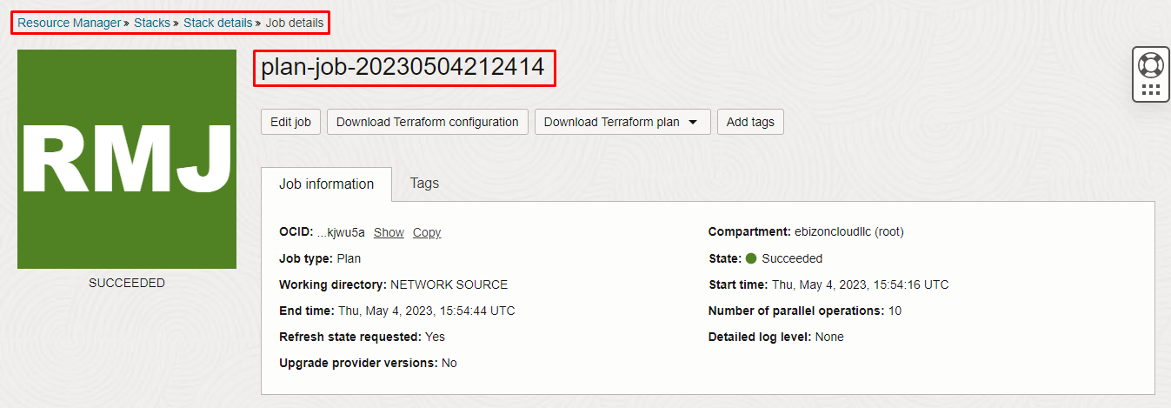

Apply the Job

Once the “plan” is success, now click “Apply”

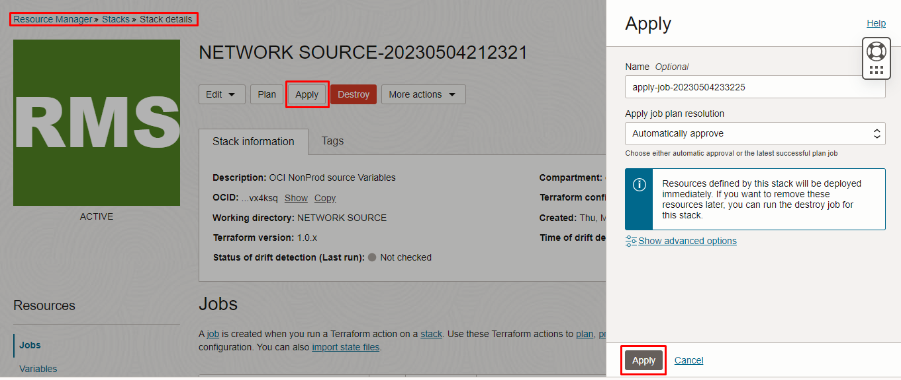

Verify the Apply is successful.

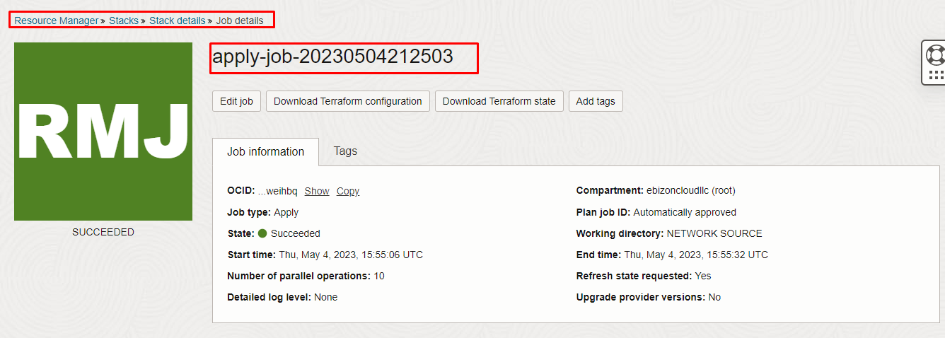

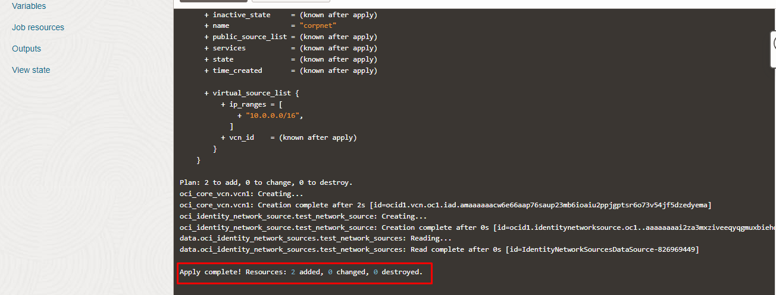

Verify in the Console

Go to OCI Console Networking Virtual Cloud Networks

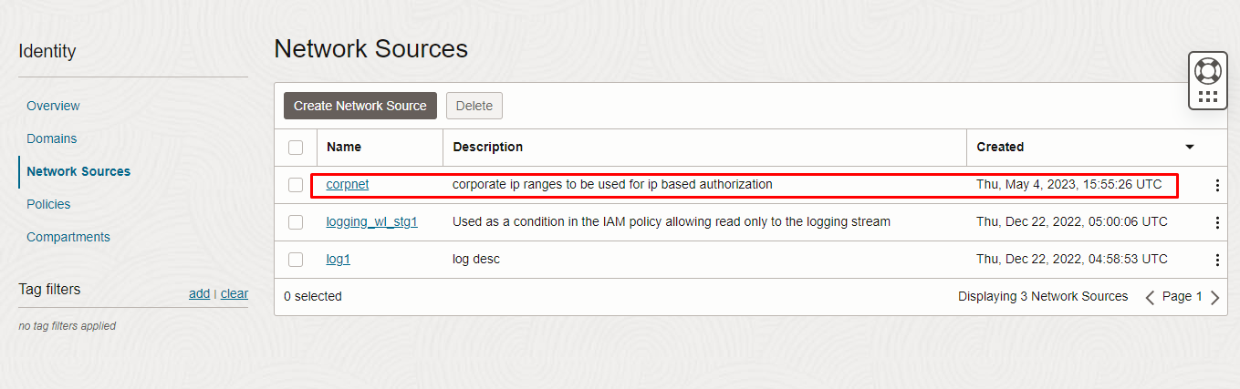
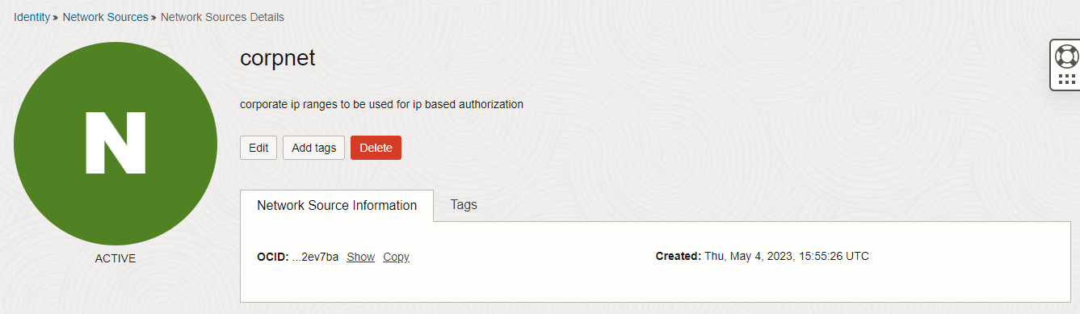
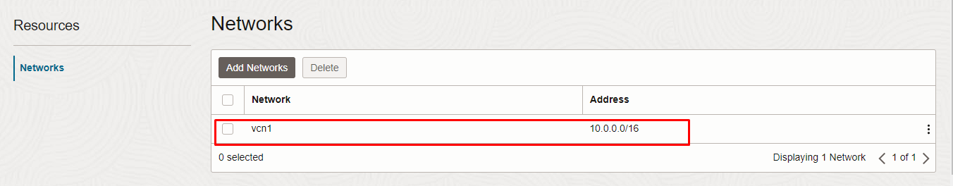

Destroy the stack

Create a destroy job in Resource Manager to release resources associated with a stack and clean up the tenancy. Once destroyed data cannot be recovered from resources.

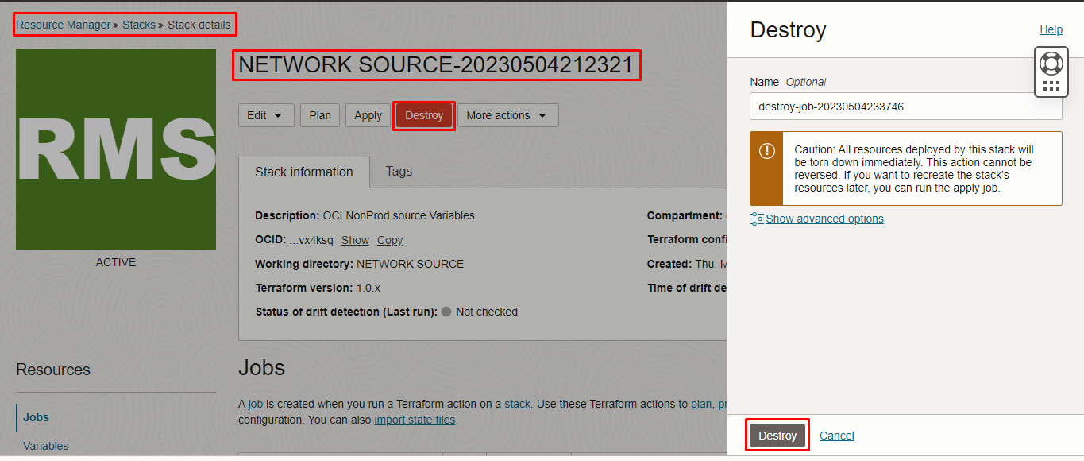

# END #

